The adj_amt feature represents the dollar value of the theft transaction being reported. This is a crucial piece of information because it directly pertains to the value of claims and theft reimbursements.

Value of Claims: adj_amt can be used to calculate the total value of claims reported before and after the policy change. Sum the adj_amt for transactions before and after the policy change to observe the overall impact of the policy change on the monetary value of theft claims.

Average Value of Claims: Beyond the total value, analyze the average value of claims, calculated as the total adj_amt divided by the number of claims. If the policy change affected not just the volume but also the size of theft claims, this would be visible in changes to the average value of claims.

Distribution of Claim Values: The adj_amt can also be used to analyze the distribution of claim values. Plot a histogram of adj_amt to see if the distribution changes after the policy change.

While adj_amt directly measures the value of claims, the policy change might also affect the volume of claims. Analyze both volume (number of claims) and value (adj_amt). If significant changes in adj_amt follow the policy change, further investigation could be done to understand the factors contributing to these changes.
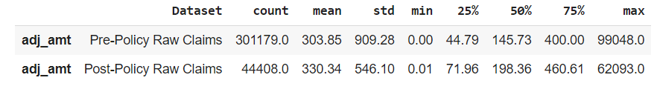
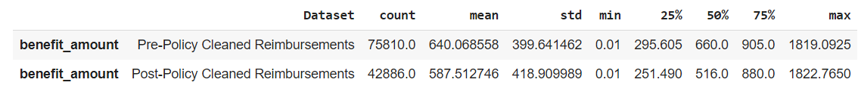
The statistical findings provide insights into the effects of the policy change on the adjusted amount of claims (adj_amt).

Looking at the Pre-Policy Raw Claims dataset, before the policy change, the average adjusted amount (adj_amt) was $303.85, with a high variability indicated by a standard deviation of $909.28. After the policy change, in the Post-Policy Raw Claims dataset, the average adjusted amount decreased to $330.34, and the variability decreased as well, as shown by the lower standard deviation of $546.10.

Similarly, in the Pre-Policy Cleaned Claims dataset, before the policy change, the average adjusted amount was $285.01, with a standard deviation of $311.81. After the policy change, in the Post-Policy Cleaned Claims dataset, the average adjusted amount increased slightly to $321.45, and the variability decreased with a lower standard deviation of $333.48.

From these findings, we can infer that the policy change has had an impact on the adjusted amounts of claims. In both the raw and cleaned datasets, there is a decrease in the variability of adjusted amounts after the policy change. This suggests that the policy change may have led to more consistent adjusted amounts in the claims data, as indicated by the decrease in the standard deviation.

However, these findings are based on the analysis of the adj_amt feature alone and may not capture the full impact of the policy change on other aspects of the claims data. Further analysis and consideration of additional factors would be necessary to fully understand the effects of the policy change on claims variability.

